Fuzz Testing
Create Test Procedure

Revision
Version 2
6/3/26 1:42 PM

Author
Charles Wilson

Abstract
This document describes the procedure used to perform the create test activity described in the AVCDL ^{[1]} Fuzz Testing Report ^{[2]} secondary document.

Group / Owner
Security / Security Architect

Motivation
This document is motivated by the need to have runtime-specific, cybersecurity-related feedback in the development of software for use within safety-critical, cyber-physical systems.
Note: Within the context of this document, the terms security and cybersecurity are used interchangeably. It is presumed that the term security is being used in reference to cybersecurity and not physical security.

License
This work was created by Torc Robotics and is licensed under the Creative Commons Attribution-Share Alike (CC BY-SA-4.0) License.
https://creativecommons.org/licenses/by/4.0/legalcode

Audience
The audience of this document is the cybersecurity practitioner who will be conducting cybersecurity-specific fuzz testing.

Completeness of Output
Since fuzz testing is an as-is analysis, it is critical to ensure that the information gathered is as accurate and complete as possible. As with any cybersecurity assessment, it is not the place of the fuzz testing SME to make assumptions on the part of engineering. All information should be sourced from and confirmed by the owner of the element under consideration.

Disposition of Output
This activity does not produce documentation as an output.

Entry Criteria
This document assumes that the reader understands the purpose of cybersecurity-specific fuzz testing. Further, that the reader has read and understood the AVCDL Fuzz Testing Report secondary document.

Prerequisites – Fuzz Testing SME

Qualifications
It is required that the fuzz testing SME is both a qualified and trained security architect (shown above on title page as Owner) as defined by the NIST NCWF role SP-ARC-002 and detailed in the NCWF Roles - Security Architect section of the AVCDL Background Material elaboration document ^{[4]}.

Knowledge
It is required that the fuzz testing SME understands the purpose of cybersecurity-specific fuzz testing.

Background Information
It is required that the fuzz testing SME has read and understands the AVCDL Fuzz Testing Report secondary document. Additionally, that the fuzz testing SME has taken training relevant to this activity.

Prerequisites – DevOps SME

Qualifications
It is required that the DevOps SME is both a qualified and trained DevOps SME with expertise in the build system used for the element under consideration in the context of the fuzz testing framework being employed.
Note: The specific qualifications and training of DevOps SMEs necessary to assert expertise in providing accurate information regarding the build system used for the element under consideration is outside the scope of this document.
Note: The DevOps group is responsible for determining and making available the appropriate SME for the modifications to build system needed for the tool under consideration.

Knowledge
It is required that the DevOps SME have expertise in the build system used for the element under consideration in the context of the fuzz testing framework being employed.

Prerequisites – Input Materials
It is required that the build file has been updated to make the appropriate fuzz testing frameworks available for use with the element under consideration as a result of the fuzz testing settings establishment activity.

Create Test Activity
The workflow diagram for the create test activity of the Fuzz Testing process is shown below.
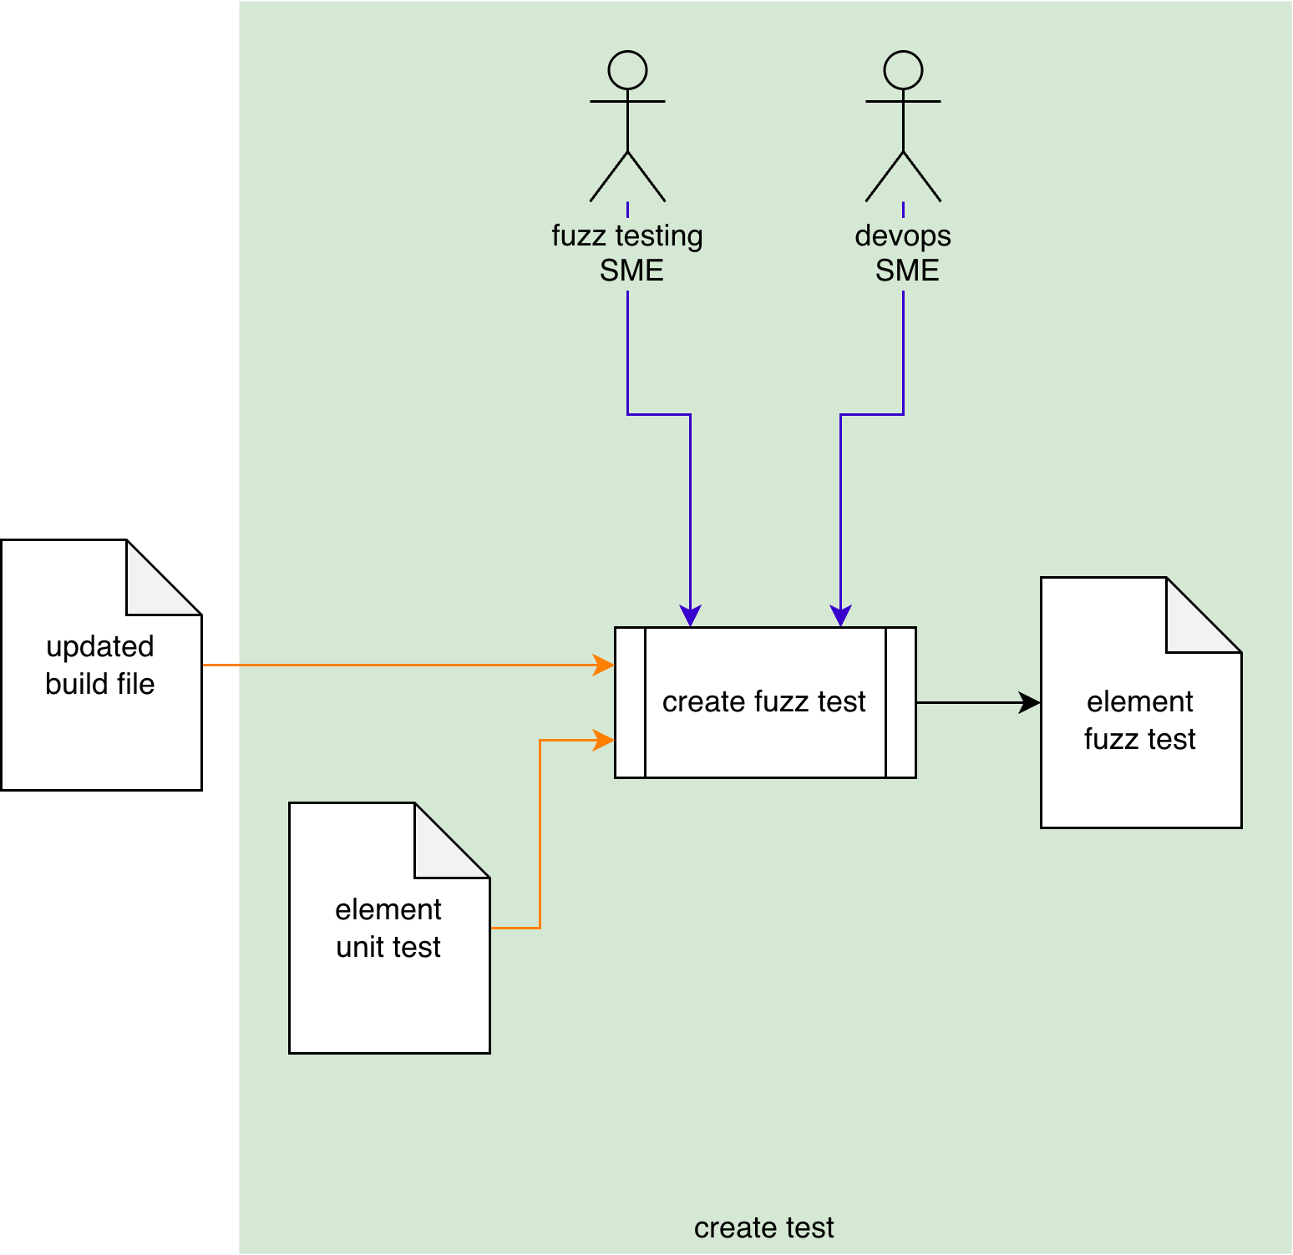
Using the Updated Build File created in the Fuzz Testing - Establish Settings activity ^{[3]}, the Fuzz Testing and DevOps SMEs will take the Element Unit Test and make adjustments to allow for use in a fuzz testing context. An Element Fuzz Test will be produced.
Note: In some cases, the Fuzz Testing SME may perform this activity alone or the activity may even be fully automated.
Note: The types of tests available are determined by the fuzz testing frameworks selected for use with the element.
Note: The scope of the element under consideration may be as small as a single function, or as large as the entire project.

Methodology
Because of the diversity of individual fuzz testing frameworks, the implementation of this activity is deferred to the documentation provided by the chosen fuzz testing framework.

Considerations
The following need to be taken into consideration when creating fuzz tests.
Note: It is presumed that all considerations presented in the Secure Settings process and Fuzz Testing – Establish Settings procedure apply here also.

Unit Tests
Since a fuzz test extends the concept of a unit test, it is presumed that there exists a unit test for the functions of the element for which the fuzz tests are being created.
Note: It is highly recommended that fuzz testing only be conducted on those elements for which development has provided unit tests as these provide baselines for expected behavior.

Detection Limitations
It is important to keep in mind that fuzz test non-crashing behavior does not indicate the absence of a vulnerability. It is recommended that fuzz testing be used in conjunction with dynamic analysis tooling ^{[5]} in order to detect anomalous behavior.

Cybersecurity Relevancy
When creating tests for an element, it is important to limit the activity to those elements which are cybersecurity-relevant. Otherwise, this activity is simply normal development quality assurance which is outside the scope of the product cybersecurity team.
Note: In the context of fuzz testing, cybersecurity relevancy goes beyond the general element-level determination ^{[6]}. Fuzz testing cybersecurity relevancy should be determined for the functions within the element.
Concurrency
When a fuzz testing framework supports parallel execution of multiple instances of a fuzz test, the impact on the resource footprint must be given extra attention.
Note: If the fuzz testing framework’s concurrency is configurable, it should be appropriately set to remain within desired bounds.

Test Scope
Fuzz tests should be scoped as minimally as possible in order to allow for issues to be reproduced and resolved efficiently. It is better to have more, highly-focused tests than fewer, generic ones.

Automation
Given the build file with the updated settings, and knowledge about the element that fuzz testing is being applied to, it may be feasible to apply automation capable of using this information to generate fuzz tests.
Note: The specifics of automation are outside the scope of this document.

Exit Criteria
This procedure is considered complete once the Element Fuzz Test has been created.

References
- AVCDL (AVCDL primary document)
- Fuzz Testing Report (AVCDL secondary document)
- Fuzz Testing Establish Settings Procedure (AVCDL tertiary document)
- AVCDL Background Material (AVCDL elaboration document)
- Dynamic Analysis Report (AVCDL secondary document)
- Element Cybersecurity Relevancy (AVCDL secondary document)

